Eye Blink Drive Protection System

There has been a very large increase in road accidents due to drowsiness of drivers while driving which leads to enormous fatal accidents. The driver loses control when he falls asleep which leads to an accident. This is because when the driver is not able to control his vehicle at a very high speed on the road. Driver in-alertness is an important cause of most accidents related to vehicle crashes. Driver fatigue resulting from sleep deprivation or sleep disorders is an important factor in the increasing number of accidents on today’s roads. A drowsy driver warning system can form the basis of the system to possibly reduce the accidents related to driver drowsiness.
Requirments:
- Glass with eyeblink sensor
- Arduino Nano
- L298N Motor Driver
- 4 Wheel Car
- DC Motor

Glass Eyeblinkm Sensor:
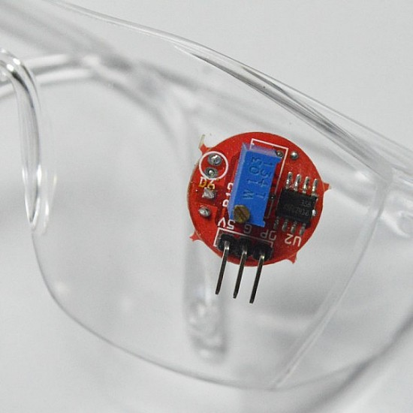
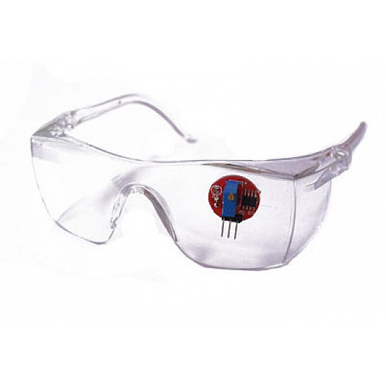
EYE BLINK SENSOR: This eye blink sensor is based on IR. It consists of an IR transmitter and IR receiver. The eye blink sensor illuminates the eye with infrared light and monitors the changes in the reflected light. The infrared light reflected from the eye is used to determine the results.
Arduino Nano: 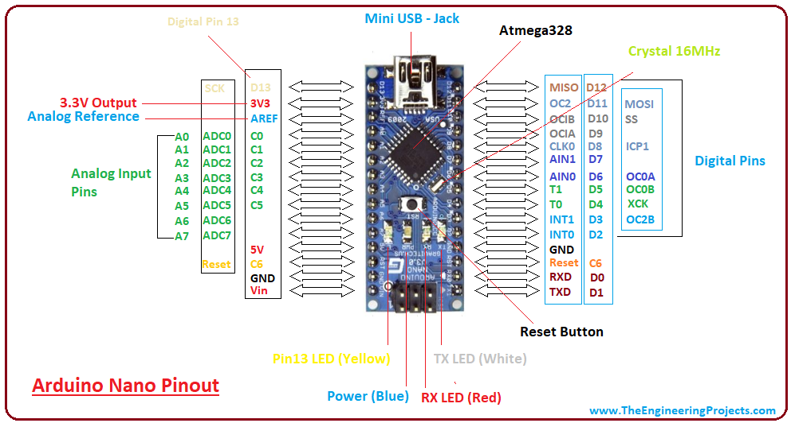

The Arduino Nano is Arduino's classic breadboard friendly designed board with the smallest dimensions. The Arduino Nano comes with pin headers that allow for an easy attachment onto a breadboard and features a Mini-B USB connector.
Input/output:
There are total 14 digital Pins and 8 Analog pins on your Nano board. The digital pins can be used to interface sensors by using them as input pins or drive loads by using them as output pins. A simple function like pinMode() and digitalWrite() can be used to control their operation. The operating voltage is 0V and 5V for digital pins. The analog pins can measure analog voltage from 0V to 5V using any of the 8 Analog pins using a simple function like analogRead().
These pins apart from serving their purpose, can also be used for special purposes, which are discussed below:
- Serial Pins 0 (Rx) and 1 (Tx): Rx and Tx pins are used to receive and transmit TTL serial data. They are connected with the corresponding ATmega328P USB to TTL serial chip.
- External Interrupt Pins 2 and 3: These pins can be configured to trigger an interrupt on a low value, a rising or falling edge, or a change in value.
- PWM Pins 3, 5, 6, 9 and 11: These pins provide an 8-bit PWM output by using analogWrite() function.
- SPI Pins 10 (SS), 11 (MOSI), 12 (MISO) and 13 (SCK): These pins are used for SPI communication.
- In-built LED Pin 13: This pin is connected with a built-in LED. When pin 13 is HIGH – LED is on and when pin 13 is LOW, it is off.
- I2C A4 (SDA) and A5 (SCA): Used for IIC communication using Wire library.
- AREF: Used to provide reference voltage for analog inputs with analogReference() function.
- Reset Pin: Making this pin LOW, resets the microcontroller.

DC Motor:
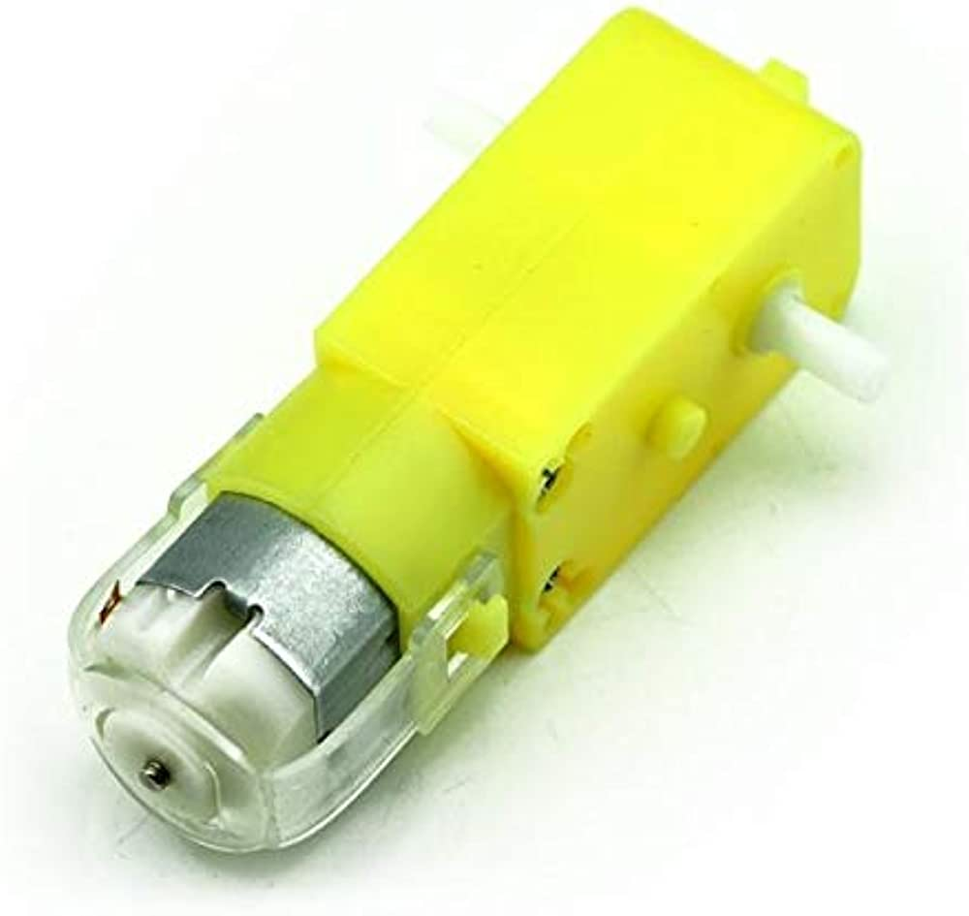
What is a DC Gear Motor? A gear motor is an all-in-one combination of a motor and gearbox. The addition of a gearbox to a motor reduces the speed while increasing the torque output. The most important parameters in regard to gear motors are speed (rpm), torque (lb-in) and efficiency (%).

L298N Motor Driver:

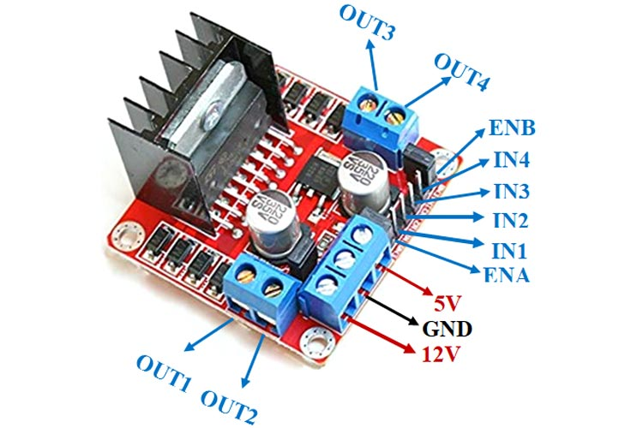
The image above is an L298N Motor Driver. The L298N is a dual H-Bridge motor driver which allows the speed and the direction control of two DC motors at the same time. We can also use this motor driver to control one stepper motor.
Circuit Diagram:
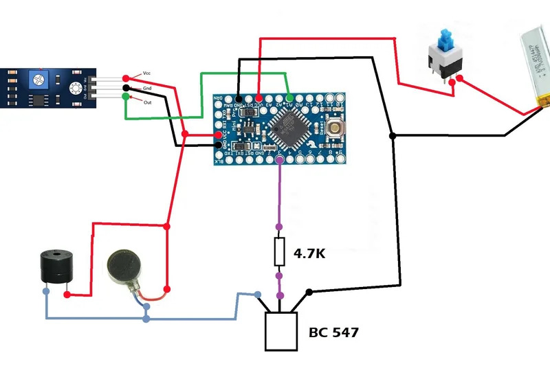
Code:
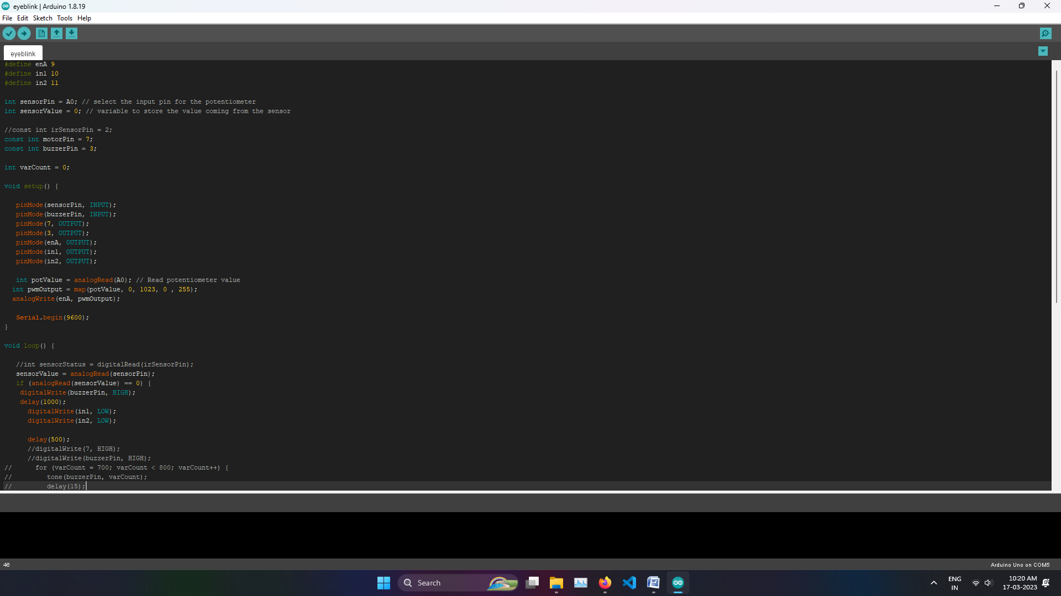
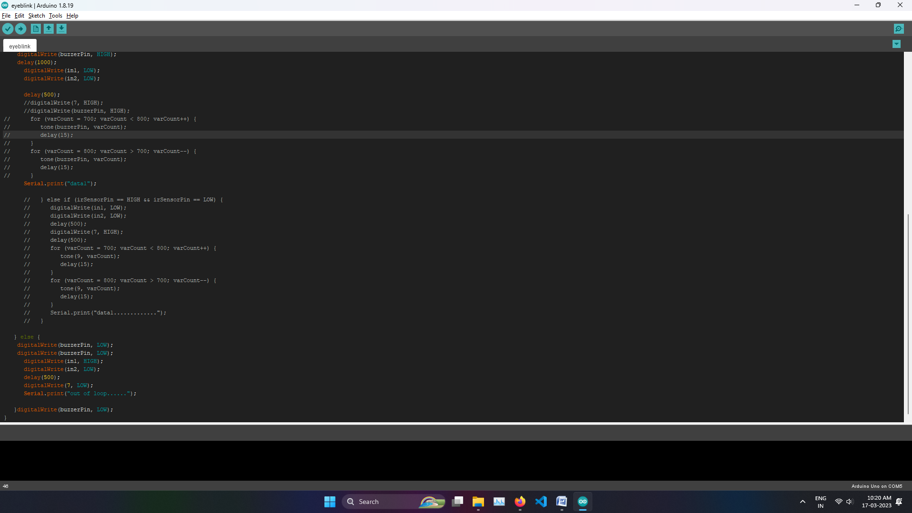
Conclusion:
The implementation of driver alert system, with eyeblink sensor and arduino nano processor has been successfully verified. The system can also be used in other applications like production industries with heavy machineries involving night shifts and the like. With the advancing technology the monitoring of the system can be extended to n number of contacts/ places, making safety of the person involved the highest priority.

